

BHARATI VIDYAPEETH’S
INSTITUTE OF COMPUTER APPLICATIONS & MANAGEMENT
(Affiliated to Guru Gobind Singh Indraprastha University, Approved by AICTE, New Delhi)

Object Oriented Software Engineering Lab
(MCA- 164)
Practical File

Submitted To: Submitted By:
Dr. Ritika Wason Mukul ( 06911604424 )
(Deputy Director & Associate Professor) MCA 2nd Sem, Sec B

I NDEX

S.No. | Problem Description | Date | Sign.
Q1 | Create a Use Case Diagram for a Digital Sound Recorder with the following main features:  1. The recorder stores up to 10 messages  2. Each message is max. 2 minutes long  3. The user can record message  4. Recording of a message end after 2 minutes or when the user stops recording  5. Recording destroys the original message at chosen slot  6. Sufficient level of battery is checked before recording message  7. Message of a given slot can be replayed  8. Sufficient level of battery is checked before replaying message  9. Messages can be locked/unlocked  10. Locked messages cannot be deleted or over-written by recording to the same slot User uses LCD display and buttons to interact with recorder
Q2 | Formulate use case descriptions for 5 major use cases identified in the digital sound recorder
Q3 | As the head of Information Technology at Acme Airlines, you are tasked with building a new booking system to replace the existing system. Acme needs a new system to allow employees to book ticket electronically and check the status of the booked tickets.  The new system will be state of the art and will have a Windows-based desktop interface to allow employees to enter booking details and view employee details. The system will run on individual employee desktops throughout the entire company. For reasons of security and auditing, employees can access only their data. The employees would only be able to view their information, and for any changes they would have to send an E-Mail to the administrator. Administrator would only have the right to make any changes in the records.  For the cost being a factor Acme wants to use their old server with the existing database. The system will retain information on all employees in the company.  The administrator maintains employee information. He is responsible for adding new employees, deleting employees and changing all employee information such as name, address, and paycheck generation, as well as running administrative reports
Q4 | Consider the following use-case of a travel agency. Use-Case Name: Ticket Purchasing Description:  1. The use-case begins when the customer calls the travel agency to ask it to issue a ticket that (s)he has booked.  2. The travel agency operator asks the customer to give his/her booking number.  3. The customer gives the booking number.  4. The operator types in the booking number and the flight reservation system displays the details of the reservation made.  5. The operator asks the customer to confirm the details of the reservation made.  6. The customer confirms the reservation made.  7. The operator asks the customer for a credit card number.  8. The customer gives his/her credit card number.  9. The operator types in the customer's credit card number and when the system confirms that the credit card transaction has been authorized (s)he asks the system to print the tickets, the details of the flights, and an invoice.  10. When the system confirms that the requested items have been printed, the operator informs the customer that the tickets have been issued.  Think of at least two alternative courses of events for this use-case. Describe the alternative courses as separate use-cases. Modify the description of the original usecase to make evident where exactly these alternative use-cases may be called and under which conditions. Create a use-case diagram to illustrate the relationships between the alternative use-cases and the use-case given.
AQ1 | Create a use case diagram for a restaurant ordering and billing system?
Q5 | Create a Class Diagram for a Digital Sound Recorder with the following main features:  1. The recorder stores up to 10 messages  2. Each message is max. 2 minutes long  3. The user can record message  4. Recording of a message end after 2 minutes or when the user stops recording  5. Recording destroys the original message at chosen slot  6. Sufficient level of battery is checked before recording message  7. Message of a given slot can be replayed  8. Sufficient level of battery is checked before replaying message  9. Messages can be locked/unlocked  10. Locked messages cannot be deleted or over-written by recording to the same slot User uses LCD display and buttons to interact with recorder
Q6 | Forward engineer the model obtained in Q5 to automatically generate equivalent Java stub Code?
Q7 | Purpose: Describe major services (functionality) provided by a hospital's reception.  Summary: Hospital Management System is a large system including several subsystems or modules providing variety of functions. Hospital Reception subsystem or module supports some of the many job duties of hospital receptionist. Receptionist schedules patient's appointments and admission to the hospital, collects information from patient upon patient's arrival and/or by phone. For the patient that will stay in the hospital ("inpatient") she or he should have a bed allotted in a ward. Receptionist may also receive and process patient’s payments, record them and provide receipts. She also is responsible to file insurance claims and generate medical reports.  a. Make the use case diagram  b. Provide description for at least 04 use cases  c. Make the class diagram  d. Generate Java stub code  e. Create Object Diagram
Q8 | Create an object diagram for a Digital Sound Recorder with the following main features:  1. The recorder stores up to 10 messages  2. Each message is max. 2 minutes long  3. The user can record message  4. Recording of a message end after 2 minutes or when the user stops recording  5. Recording destroys the original message at chosen slot  6. Sufficient level of battery is checked before recording message  7. Message of a given slot can be replayed  8. Sufficient level of battery is checked before replaying message  9. Messages can be locked/unlocked  10. Locked messages cannot be deleted or over-written by recording to the same slot User uses LCD display and buttons to interact with recorder
Q9 | Create a package diagram for the Digital Sound Recorder in AP1
Q10 | Create an activity diagram for record message use case of AP1?
Q11 | Create an activity diagram for any two use cases of Hospital Reception Subsystem in CP1
Q12 | Create a sequence diagram for the playback message use case of AP1?
Q13 | Create a sequence diagram for any two use cases of Hospital Reception Subsystem in CP1
Q14 | Create a state diagram for any two use cases of Hospital Reception Subsystem in CP1
Q15 | Create a state diagram for a BANK ATM machine?
Q16 | Create a communication diagram for the playback message use case of AP1?
Q17 | Create a communication diagram for any two use cases of Hospital Reception Subsystem in CP1?
Q18 | Create a component diagram for the Hospital Reception Subsystem?
Q19 | Create a component diagram for ATM Machine
Q20 | Create a deployment diagram for the Hospital Reception Subsystem?
Q21 | Create a deployment diagram for ATM machine?
Q22 | Create a PERT Chart on PowerPoint for the following.  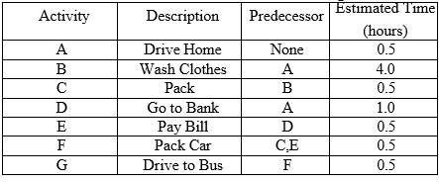
Q23 | Create a GANTT Chart on PowerPoint for the following  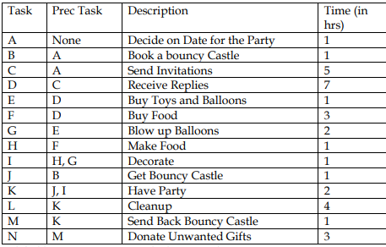  • label hours 0 to 30 across the horizontal axis  • Mark a review stage at hour 14 to monitor the progress  • Assume and illustrate that tasks A, B, C and D have been completed at hour 14  State which tasks are ahead and which tasks are behind schedule

Q1. Create a Use Case Diagram for a Digital Sound Recorder with the following main features:
1. The recorder stores up to 10 messages
2. Each message is max. 2 minutes long
3. The user can record message
4. Recording of a message end after 2 minutes or when the user stops recording
5. Recording destroys the original message at chosen slot
6. Sufficient level of battery is checked before recording message
7. Message of a given slot can be replayed
8. Sufficient level of battery is checked before replaying message
9. Messages can be locked/unlocked
10. Locked messages cannot be deleted or over-written by recording to the same slot User uses LCD display and buttons to interact with recorder

Solution :-

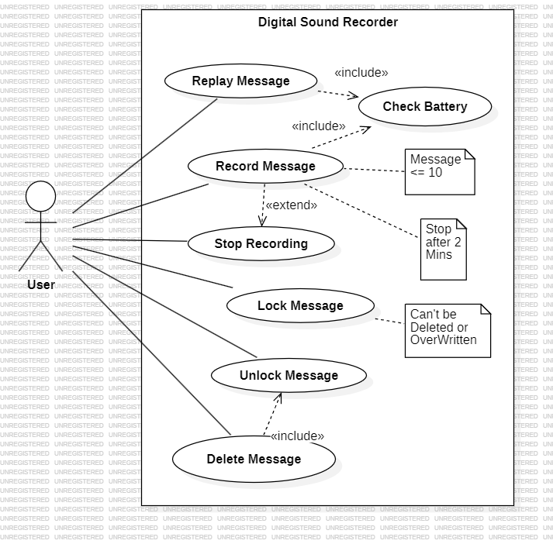

Q2. Formulate use case descriptions for 5 major use cases identified in the digital sound recorder

Solution :-

USE CASES | DESCRIPTION
Record Message | The user can record a message to a specific slot in the recorder, with a maximum duration of 2 minutes. The recording stops automatically after 2 minutes or when manually stopped by the user. Preconditions include having sufficient battery and the target slot being unlocked. Postconditions include storing the message in the selected slot and overwriting the previous message in the slot if it was unlocked.
Replay Message | The user can replay a stored message from a specified slot. Preconditions include having sufficient battery and the selected slot containing a message. Postconditions include playing the selected message through the recorder.
Lock/Unlock Message | The user can lock or unlock a message in a specified slot to prevent accidental deletion or overwriting. Preconditions require selecting a valid slot. Postconditions include marking the slot as locked or unlocked based on the user's action. Locked slots cannot be overwritten or deleted.
Check Battery Level | The system checks the battery level to ensure there is enough power to perform operations like recording or replaying a message. There are no specific preconditions as this is implicitly checked before recording or replaying. If the battery level is sufficient, the operation proceeds;  Otherwise , an error or warning is displayed
Delete Message | The user can delete a message from a specific slot, but locked messages cannot be deleted. Preconditions require that the slot is not locked and contains a message. Postconditions include the removal of the message from the specified slot.

Q3. As the head of Information Technology at Acme Airlines, you are tasked with building a new booking system to replace the existing system. Acme needs a new system to allow employees to book ticket electronically and check the status of the booked tickets.
The new system will be state of the art and will have a Windows-based desktop interface to allow employees to enter booking details and view employee details. The system will run on individual employee desktops throughout the entire company. For reasons of security and auditing, employees can access only their data. The employees would only be able to view their information, and for any changes they would have to send an E-Mail to the administrator. Administrator would only have the right to make any changes in the records.
For the cost being a factor Acme wants to use their old server with the existing database. The system will retain information on all employees in the company.

Solution :-

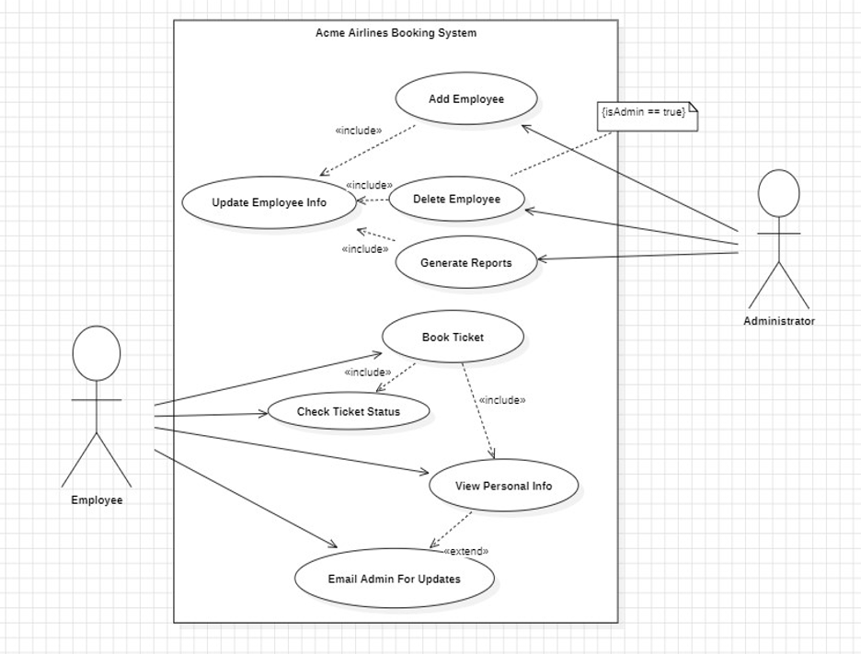

Q4. Consider the following use-case of a travel agency. Use-Case Name: Ticket Purchasing Description:
1. The use-case begins when the customer calls the travel agency to ask it to issue a ticket that (s)he has booked.
2. The travel agency operator asks the customer to give his/her booking number.
3. The customer gives the booking number.
4. The operator types in the booking number and the flight reservation system displays the details of the reservation made.
5. The operator asks the customer to confirm the details of the reservation made.
6. The customer confirms the reservation made.
7. The operator asks the customer for a credit card number.
8. The customer gives his/her credit card number.
9. The operator types in the customer's credit card number and when the system confirms that the credit card transaction has been authorized (s)he asks the system to print the tickets, the details of the flights, and an invoice.
10. When the system confirms that the requested items have been printed, the operator informs the customer that the tickets have been issued.
Think of at least two alternative courses of events for this use-case. Describe the alternative courses as separate use-cases. Modify the description of the original usecase to make evident where exactly these alternative use-cases may be called and under which conditions. Create a use-case diagram to illustrate the relationships between the alternative use-cases and the use-case given.

Solution :-

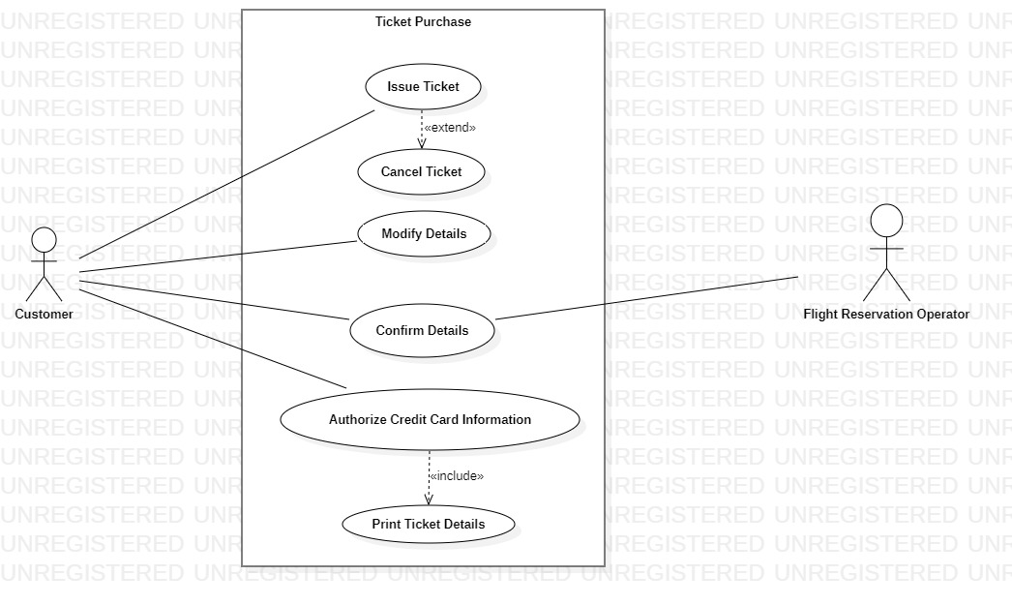

AQ1. Create a use case diagram for a restaurant ordering and billing system?

Solution :-

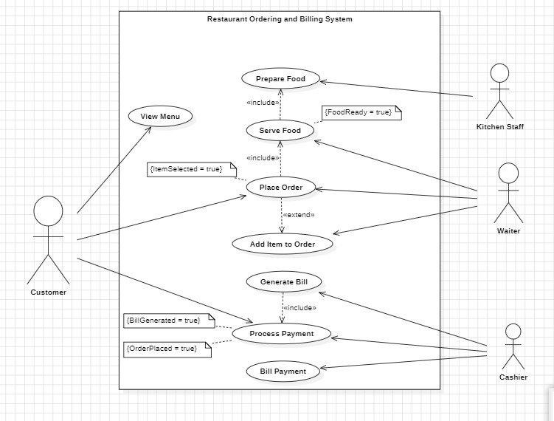

Q5. Create a Class Diagram for a Digital Sound Recorder with the following main features:
1. The recorder stores up to 10 messages
2. Each message is max. 2 minutes long
3. The user can record message
4. Recording of a message end after 2 minutes or when the user stops recording
5. Recording destroys the original message at chosen slot
6. Sufficient level of battery is checked before recording message
7. Message of a given slot can be replayed
8. Sufficient level of battery is checked before replaying message
9. Messages can be locked/unlocked
10. Locked messages cannot be deleted or over-written by recording to the same slot User uses LCD display and buttons to interact with recorder

Solution :-

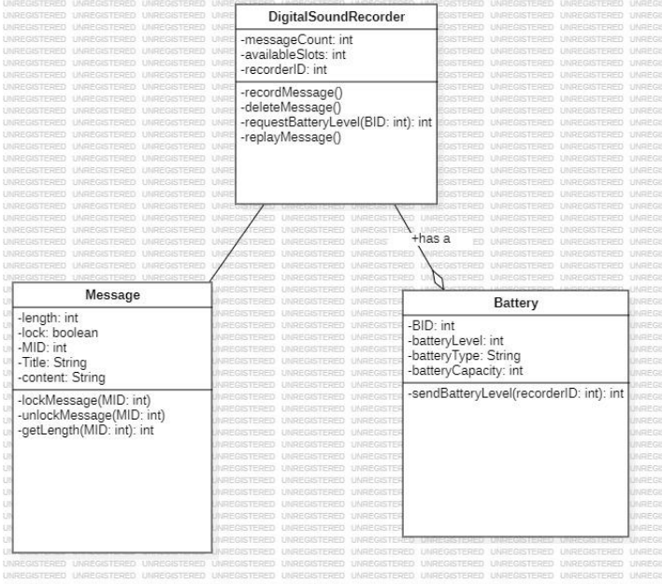

Q6. Forward engineer the model obtained in Q5 to automatically generate equivalent Java stub Code?

Solution :-

DigitalSoundRecorder.java

import java.util.*;

/**
*
*/
public class DigitalSoundRecorder {
/**
* Default constructor
*/
public DigitalSoundRecorder() {
}

/**
*
*/
private int messageCount;
/**
*
*/
private int availableSlots;
/**
*
*/
private int recorderID;

/**
*
*/
private void recordMessage() {
// TODO implement here
}

/**
*
*/
private void deleteMessage() {
// TODO implement here
}

/**
* @param BID
* @return
*/
private int requestBatteryLevel(int BID) {
// TODO implement here
return 0;
}

/**
*
*/
private void replayMessage() {
// TODO implement here
}
}

Message.java

import java.util.*;

/**
*
*/
public class Message {
/**
* Default constructor
*/
public Message() {
}

/**
*
*/
private int length;
/**
*
*/
private boolean lock;
/**
*
*/
private int MID;
/**
*
*/
private String Title;
/**
*
*/
private String content;

/**
* @param MID
*/
private void lockMessage(int MID) {
// TODO implement here
}

/**
* @param MID
*/
private void unlockMessage(int MID) {
// TODO implement here
}

/**
* @param MID
* @return
*/
private int getLength(int MID) {
// TODO implement here
return 0;
}
}

Batter.java

import java.util.*;

/**
*
*/
public class Battery {
/**
* Default constructor
*/
public Battery() {
}

/**
*
*/
private int BID;
/**
*
*/
private int batteryLevel;
/**
*
*/
private String batteryType;
/**
*
*/
private int batteryCapacity;

/**
* @param recorderID
* @return
*/
private int sendBatteryLevel(int recorderID) {
// TODO implement here
return 0;
}
}

Q7. Purpose: Describe major services (functionality) provided by a hospital's reception.
Summary: Hospital Management System is a large system including several subsystems or modules providing variety of functions. Hospital Reception subsystem or module supports some of the many job duties of hospital receptionist. Receptionist schedules patient's appointments and admission to the hospital, collects information from patient upon patient's arrival and/or by phone. For the patient that will stay in the hospital ("inpatient") she or he should have a bed allotted in a ward. Receptionist may also receive and process patient’s payments, record them and provide receipts. She also is responsible to file insurance claims and generate medical reports.
a. Make the use case diagram
b. Provide description for at least 04 use cases
c. Make the class diagram
d. Generate Java stub code
e. Create Object Diagram

Solution :-

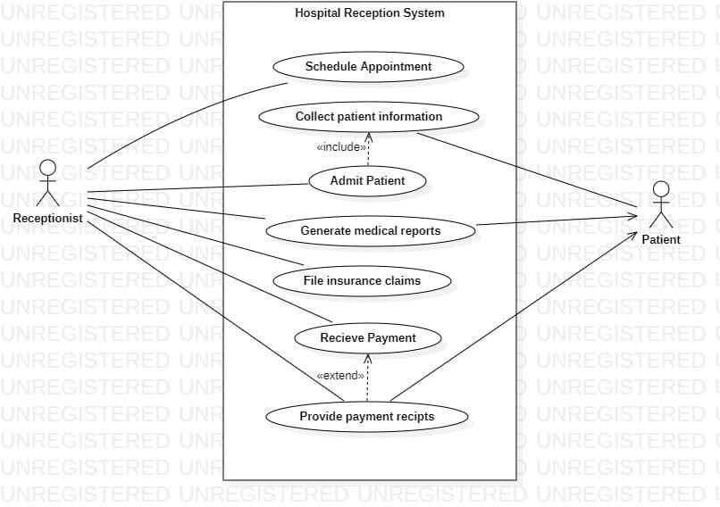
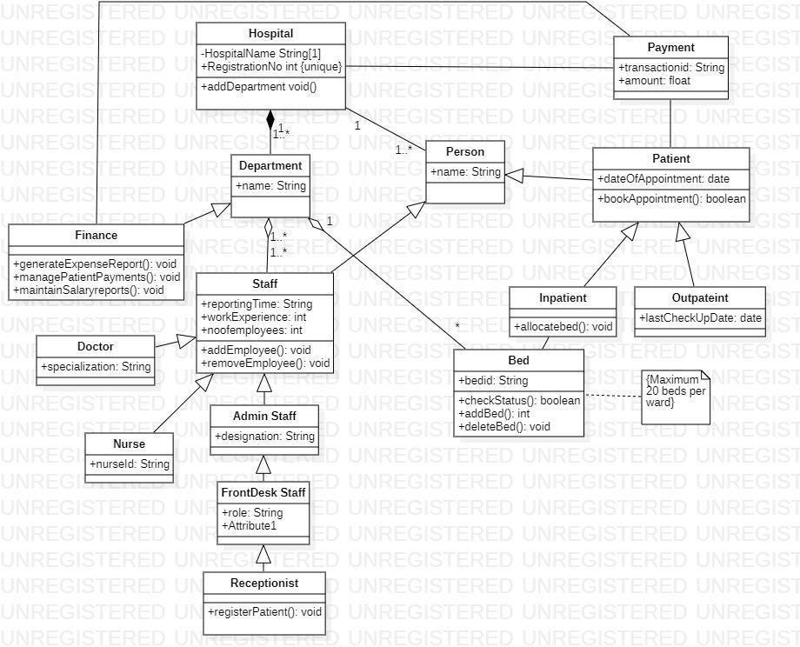

JAVA STUB CODE:

//Hospital.java importjava.util.*;

/**
*
*/
public class Hospital {
/**
* Default constructor
*/
public Hospital() {
}

/**
*
*/
private void HospitalName String[1];
/**
*
*/
public void RegistrationNoint;
/**
*
*/
public void Attribute2;
/**
*
*/
public void addDepartment

void()
{
// TODO implement here
}
}
// Department.java importjava.util.*; /**
**/

public class Department {
/**
* Default constructor
*/
public Department() {
}

/**
*
*/
public String name;
}
// Staff.java importjava.util.*;

/**
*
*/
public class Staff extends Person {
/**
* Default constructor
*/
public Staff() {
}

/**

/**
*
*/
public String reportingTime;

**/publicintworkExperience;
/**
* */
publicintnoofemployees;

/**
* @return
*/
public void addEmployee() { // TODO implement here return null;
}

/**
* @return
*/
public void removeEmployee() { // TODO implement here return null;
}
}
// Person.java importjava.util.*;

/**
*
*/
public class Person {
/**
* Default constructor
*/
public Person() {
}

/**
*
*/
public String name;
}
// Patient.java importjava.util.*;

/**
*
*/
public class Patient extends Person {
/**
* Default constructor
*/
public Patient() {
}

/**
*
*/
public date dateOfAppointment;

/**
* @return
*/
publicbooleanbookAppointment() { // TODO implement here return false;
}

}
// Inpatient.java importjava.util.*;

/**
*
*/
public class Inpatient extends Patient {
/**
* Default constructor
*/
public Inpatient() {
}

/**
* @return
*/
public void allocatebed() { // TODO implement here return null;
}
}
// Outpatient.java importjava.util.*;

/**
*
*/
public class Outpateint extends Patient {
/**
* Default constructor
*/
publicOutpateint() {
}

/**
*
*/
public date lastCheckUpDate;
}
// Doctor.java importjava.util.*;

/**
*
*/
public class Doctor extends Staff {
/**
* Default constructor
*/
public Doctor() {
}

/**
*
*/
public String specialization;
}
// Nurse.java importjava.util.*;

/**
*
*/
public class Nurse extends Staff {
/**
* Default constructor
*/

public Nurse() {
}

/**
*
*/
public String nurseId;
}
// Admin Staff.java importjava.util.*;

/**
*
*/
public class Admin Staff extends Staff {
/**
* Default constructor
*/
public Admin Staff() {
}

/**
*
*/
public String designation;
}
// FrontDesk Staff.java importjava.util.*;

/**
*
*/
public class FrontDesk Staff extends
Admin Staff
{

/**
* Default constructor
*/
publicFrontDesk Staff() {
}

/**
*
*/
public String role;
/**
*
*/
public void Attribute1;
}
// Receptionist.java importjava.util.*;

/**
*
*/
public class Receptionist extends FrontDesk Staff
{

/**
* Default constructor
*/
public Receptionist() {

}

/**
* @return
*/

public void registerPatient() { // TODO implement here return null;
}
}
// Bed.java importjava.util.*;

/**
*
*/
public class Bed {
/**
* Default constructor
*/
public Bed() {
}

/**
*
*/
public String bedid;

/**
* @return
*/
publicbooleancheckStatus() { // TODO implement here return false;
}

/**
* @return
*/
publicintaddBed() {
// TODO implement here return 0;
}

/**
* @return
*/
public void deleteBed() {
// TODO implement here return null;
}
}
// Finance.java importjava.util.*;

/**
*
*/
public class Finance extends Staff {
/**
* Default constructor
*/
public Finance() {
}

/**
* @return
*/
public void generateExpenseReport() { // TODO implement here

return null;
}

/**
* @return
*/

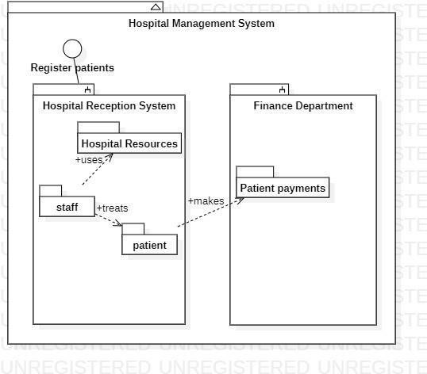

Q8. Create an object diagram for a Digital Sound Recorder with the following main features:
1. The recorder stores up to 10 messages
2. Each message is max. 2 minutes long
3. The user can record message
4. Recording of a message end after 2 minutes or when the user stops recording
5. Recording destroys the original message at chosen slot
6. Sufficient level of battery is checked before recording message
7. Message of a given slot can be replayed
8. Sufficient level of battery is checked before replaying message
9. Messages can be locked/unlocked
10. Locked messages cannot be deleted or over-written by recording to the same slot User uses LCD display and buttons to interact with recorder

Solution :-

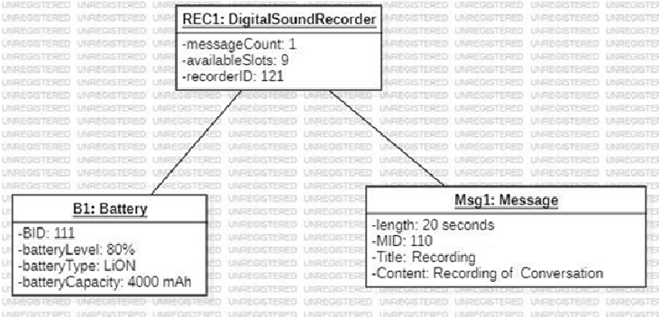

Q9. Create a package diagram for the Digital Sound Recorder in AP1

Solution :-

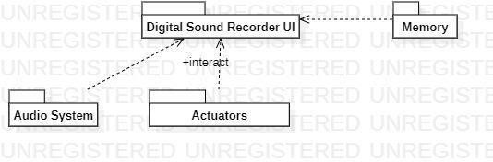
Q10. Create an activity diagram for record message use case of AP1?

Solution :-

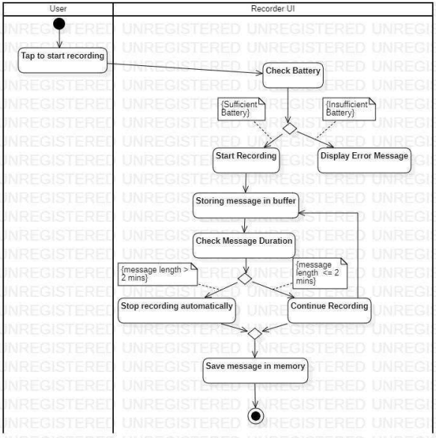

Q11. Create an activity diagram for each basic use case of the project made by you in CP1?

Solution :-

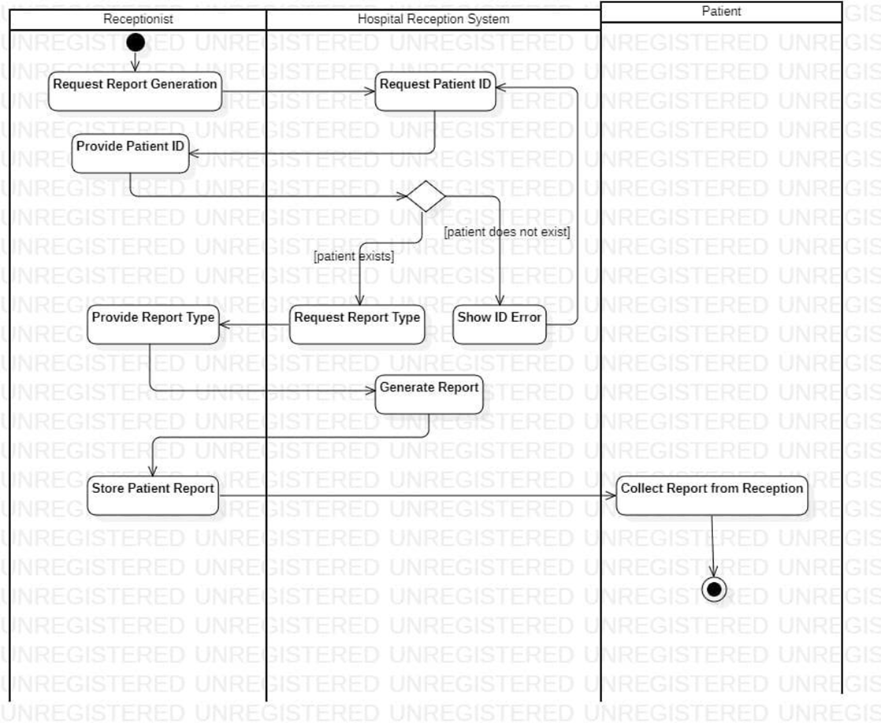

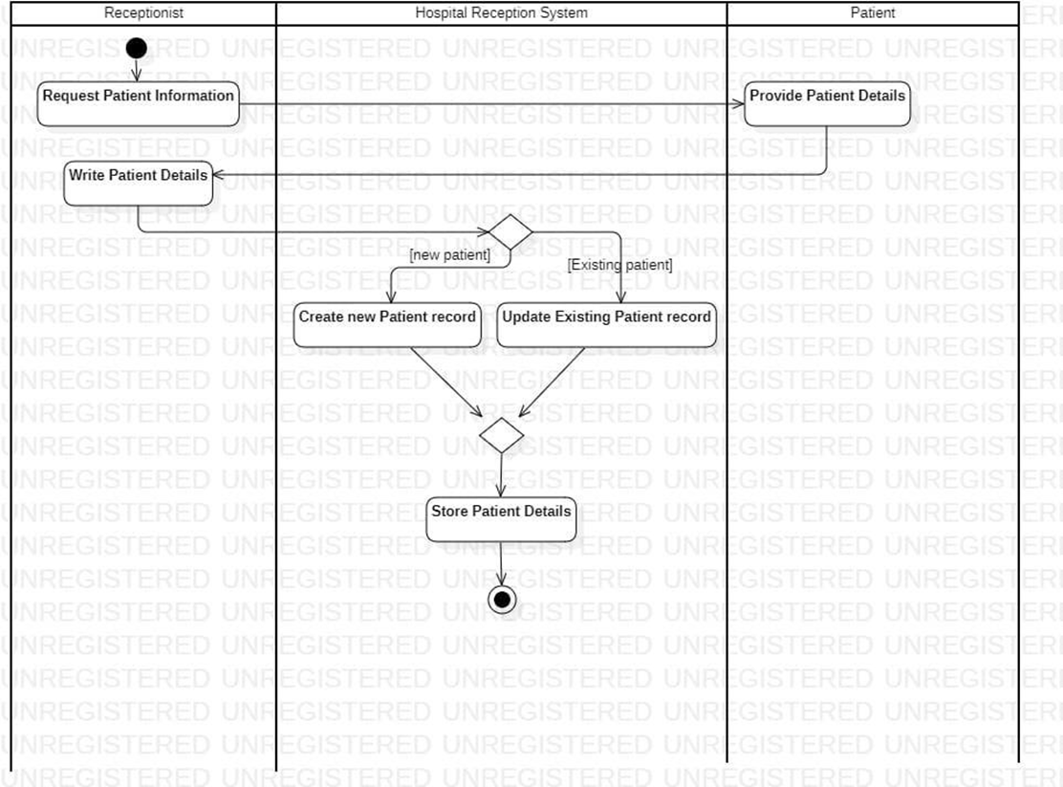

Q12. Create a sequence diagram for the playback message use case of AP1?

Solution :-

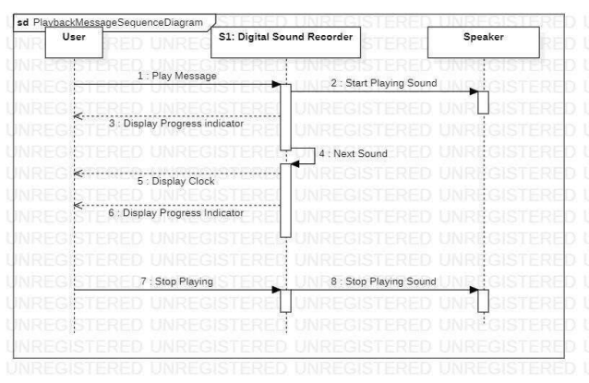

Q13. Create a sequence diagram for any two use cases of Hospital Reception Subsystem in CP1.

Solution :-

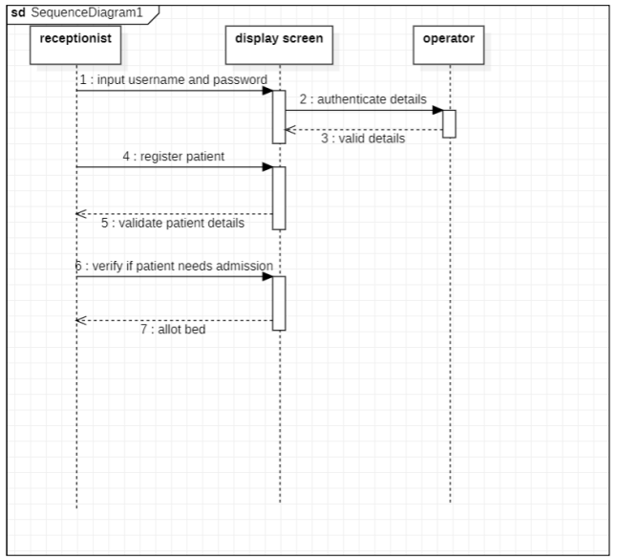

Q14. Create a state diagram for any two use cases of Hospital Reception Subsystem in CP1.

Solution :-

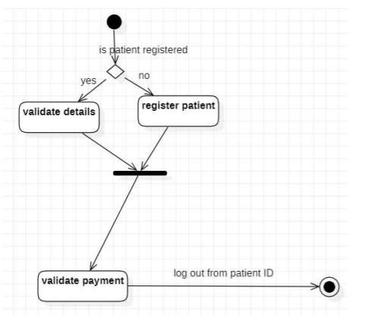

Q15. Create a state diagram for a BANK ATM machine?

Solution :-

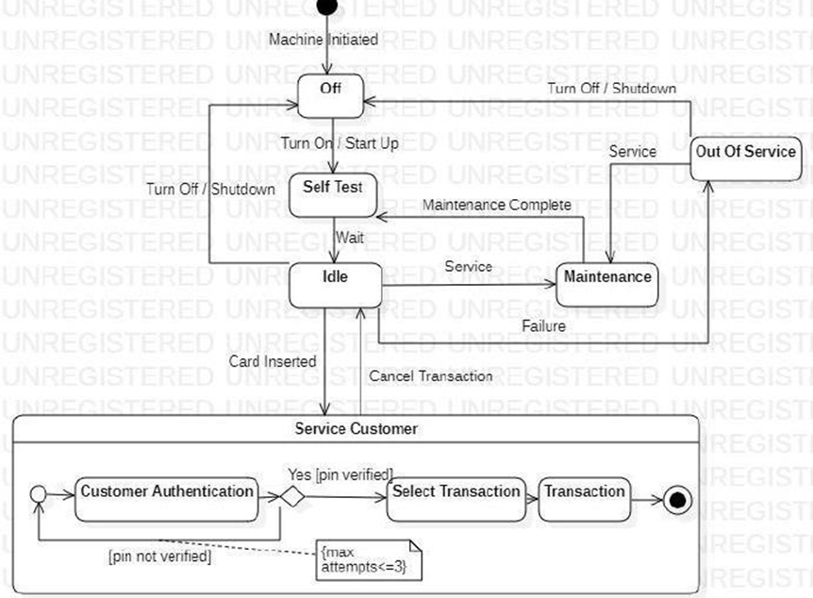

Q16. Create a communication diagram for the playback message use case of AP1?

Solution :-

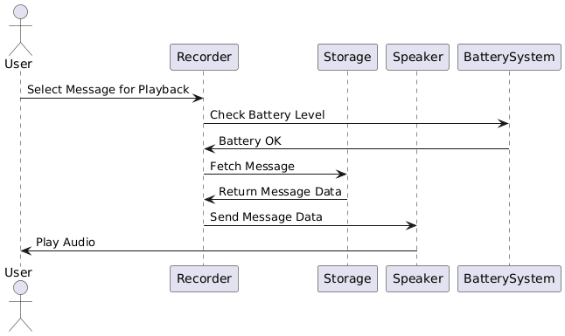

Q17. Create a communication diagram for any two use cases of Hospital Reception Subsystem in CP1?

Solution :-

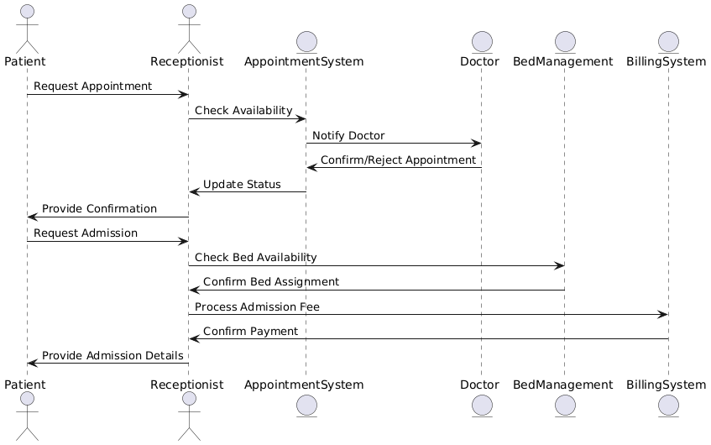

Q18. Create a component diagram for the Hospital Reception Subsystem?

Solution :-

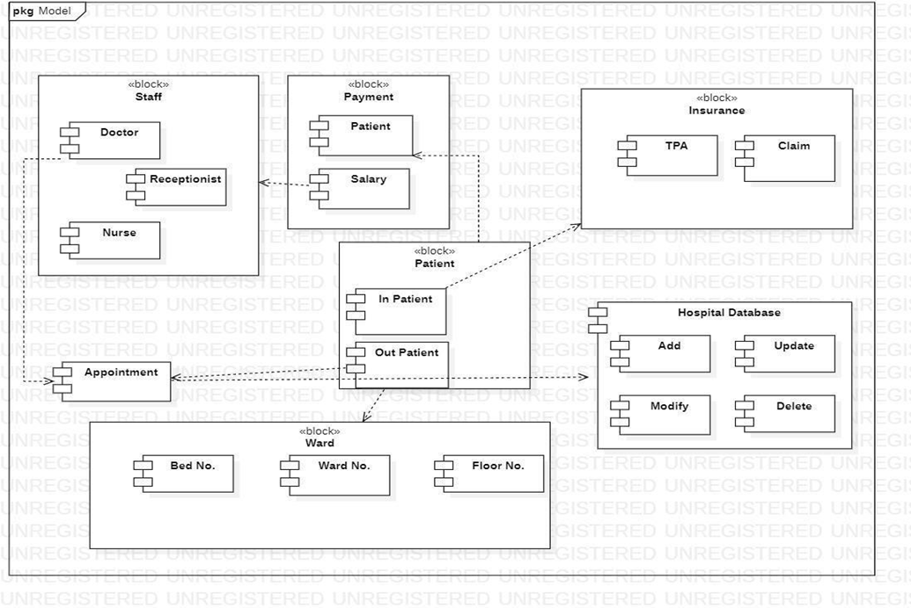

Q19. Create a component diagram for ATM Machine

Solution :-

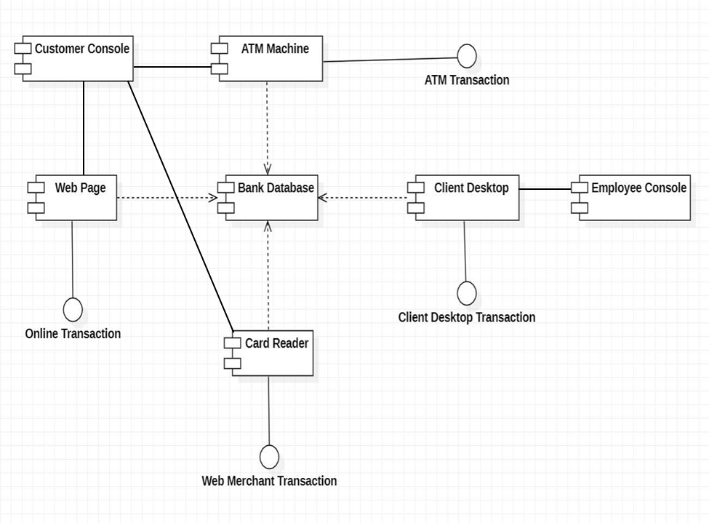

Q20. Create a deployment diagram for the Hospital Reception Subsystem?

Solution :-

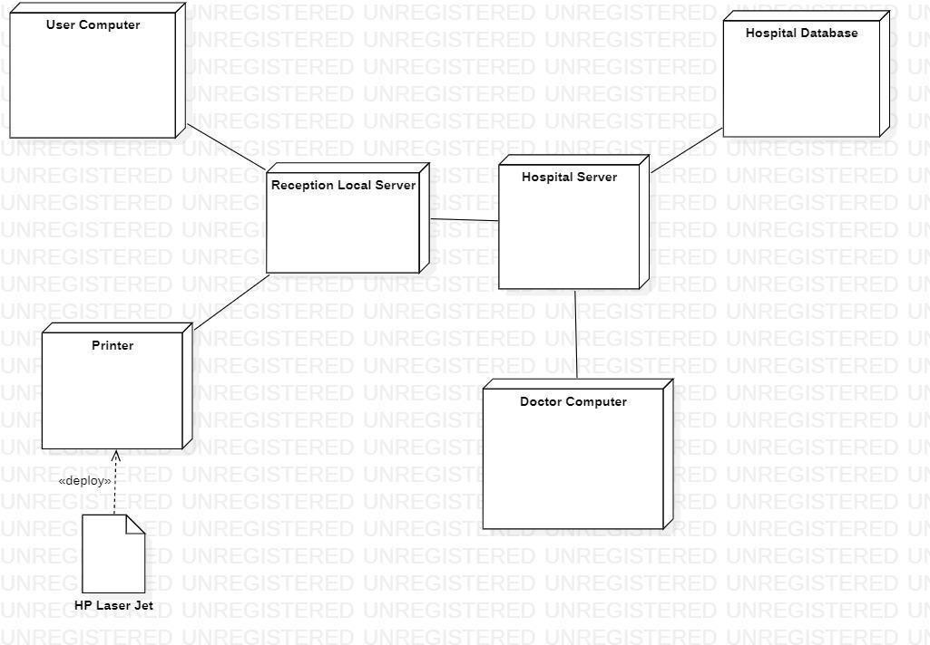

Q21. Create a deployment diagram for ATM machine?

Solution :-

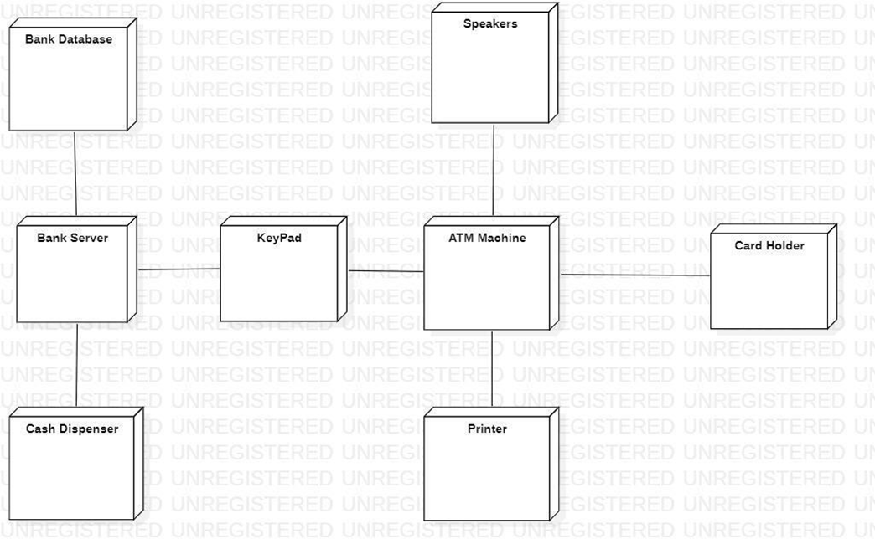

Q22. Create a PERT Chart on PowerPoint for the following
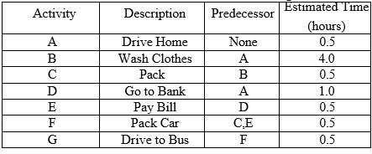

Solution :-

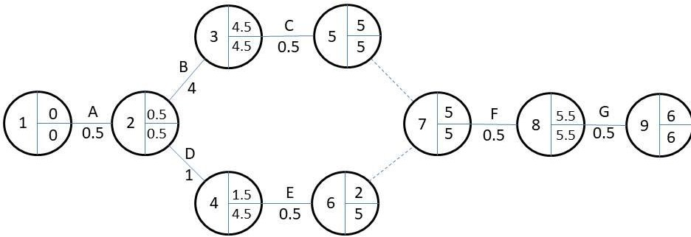

Q23. Create a GANTT Chart on PowerPoint for the following
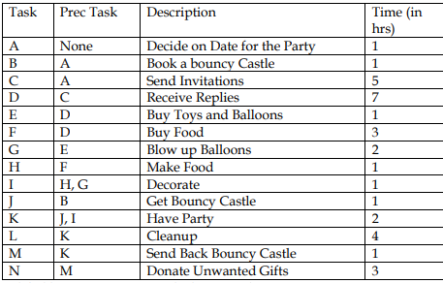
• label hours 0 to 30 across the horizontal axis
• Mark a review stage at hour 14 to monitor the progress
• Assume and illustrate that tasks A, B, C and D have been completed at hour 14
State which tasks are ahead and which tasks are behind schedule

Solution :-

